October, 2018

The Pileup
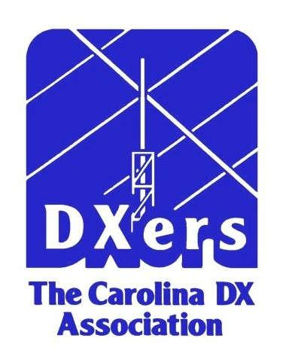

Newsletter of the CDXA
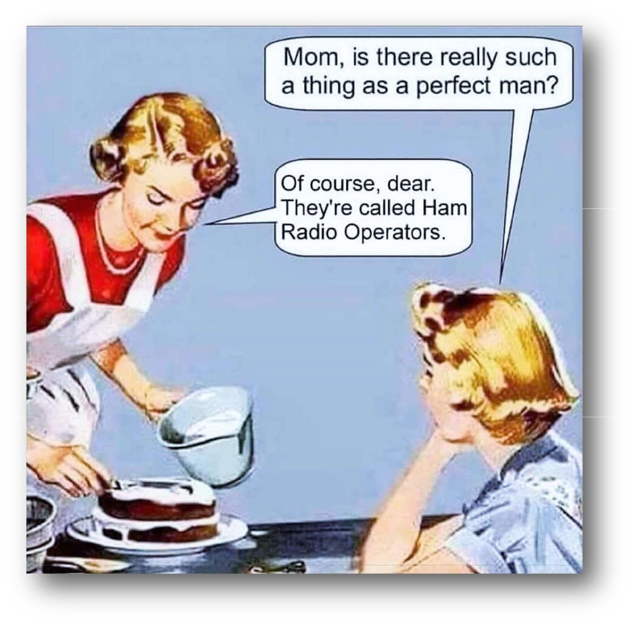

AA4ZZ | Paul Trotter | President
W4GRW | Bill Fisher | Vice-Pres.
W3ZL | Cliff Wagoner | Sec./Treas.
K4MD | Joe Simpkins | Cluster Mgr.
NV4A | John Forbus | Contest Mgr.
W3GQ | Paul Sturpe | 4th Call Area
W3GQ | Paul Sturpe | Bureau Mgr.
WB4BXW | Wayne Setzer | Webmaster
K8YC | John Scott | Editor

The cartoon to the right was sent to us by our Italian member, Fab-rizio (Brix-IN3ZNR). Brix doesn’t say whether the cartoon reflects an Italian woman’s view of an American ham, an Italian

woman’s view of an Italian ham, or an Italian’s view of what they believe American women think of their American ham husbands. One thing for sure, it is from an earlier time because of the coiffures of the sub-jects and because not too many cooks wear string pearls and a nice sweater when they bake and ice a cake. Who bakes and ices a cake now, anyway? Maybe this should be included in “The Wayback Ma-chine” section of this newsletter. With all the YLs and XYLs now in amateur radio, we surely know there is such a thing as a perfect woman!


CDXA PacketCluster & Other Communication Systems

K4MD (AR V.4 | Cluster via Telnet) | k4md.no-ip.com:23
K4MD (AR V.6 | Cluster via Telnet) | k4md.no-ip.com:7373
W4DXA (AR V.6 Cluster via Telnet) |  | w4dxa.no-ip.com:23
CDXA Repeater 147.18 MHz (+600 ) |  | W4DXA, Near Fort Mill, SC
World Wide Web Homepage |  | www.cdxa.org
Wednesday Luncheon (11:30 AM) |  | Skyland Family Restaurant, 4544 South Boulevard, Charlotte, NC

Page 1

Errata—FM13 Found!

In the August 2018 issue of The Pileup the editor inadvertently moved FM13 to be part of South Car-olina. One of those who was an operator at that activation reports FM13 includes as its land portion a tiny portion of Southport, North Carolina, not South Carolina.

Welcome New Members

We are joined by two new members this month and one returning member. Our two new members are John Gendron, KE4PLT of Rock Hill, SC and Scott Cato, K4WSC of Huntersville, NC. John has made an appearance at a luncheon or two at Skyland, so some of us have met him. Scott has been seen on the WSJT-X screen hammering away at collecting grids and DXCC entities.

Anthony Rogozinski, W4OI of Meadows of Dan, VA has been a member for a number of years, but somehow missed renewing his membership earlier this year. It seems to this old editor that Tony was somewhat involved in the disaster relief effort for Puerto Rico following the hurricane of 2017. If so, that would be enough for anyone to let a member-ship renewal slip by.

Welcome to all three additions to the CDXA Ros-ter.


The Pileup

Official Newsletter of the Carolina DX Association
Copyright 2018

Published monthly 10 times per year, excluding the months of June and December.

The purpose of the Association is to secure for the members the pleasures and benefits of associating with persons having a common interest in Amateur Radio.

Members of the CDXA shall adhere to “The Amateur’s Code” as published from time to time in The ARRL Handbook for Radio Amateurs, and shall consist of those valid licensed amateur operators having an interest in promoting amateur radio. Long distance communications (DX) is of special interest to members of the Association, but said interest is not a requirement of membership.

Yearly dues are $25.00. A second licensed Amateur family member living in the same household can join for $5.00 for a total family price of $30.00 per year. The total price for 3 or more licensed family members living in the same household is only $35.00 per year. All family members enjoy full member status. Dues are payable annually in December by check to the Secretary/Treasurer:

Cliff Wagoner, W3ZL

218 Ohenry Avenue
Davidson, NC 28036

Address, telephone, and email address changes should be directed to the Secretary/ Treasurer at the above address or via email at: jcw53@cornell.edu.

October, 2018

Ten and Twenty Years Ago. . . . .

Ten Years Ago

Has it really been 10 years since CDXA’s DX King competition was announced? Yes, then Contest Manager, Dick Williams announced in the October 2008 issue of the Pileup, “Let the Competition Begin”. . . . . . Jim Miller, K4SQR (SK) had just sold his company Comtek Systems, Inc. to DX En-gineering. Jim’s signature product was the Four Square antenna which was evident by Jim’s callsign. The Comtek name is still carried by DX Engineering on a number of Comtek products that survive to this day. . . . . Bill Fisher’s son, Josh (W4WJF), was selected to be a “youth” participant by the German team heading for Willis Island to give us VK9DWX. Josh is now married, lives in Ohio and reconnected with one of his German part-ners from the DXpedition at Dayton. His partner? Christian Janssen, President of the recently com-pleted WRTC in Germany. (The Photo of that meeting is in the July 2018 issue of the Pileup on Page 6.). . . . . The November 2008 issue of the Pileup reported CDXA had taken 1st place in Cate-gory 5E of the 2008 Field Day competition.

Twenty Years Ago

Remember the “Packet Cluster”? President Joe Simpkins was involved in converting some old GE Phoenix radios for use in connecting to the CDXA Packet Cluster at the “blazing” speed of 9600bps!. .

. . .As of October 1, 1998, three new DXCC entities were added to the DXCC list increasing the total from 328 to 331 entities. The new entities were Temotu Province, Austral Islands, and Marquesas Islands. . . . . . . Don Daso, K4ZA, provided an in-formative article in the October Pileup on using hardline in your antenna setup including some “do’s and don’ts” during installation. . . . . . The presence of the NG3K website was mentioned “again” in the November 1998 Pileup. It is still one of the most useful websites for the DXer after 20 years, and it has a link on our current website under the “HR Links” tab. This site has more information in one place on contesting activity and DX activity than you can imagine and it’s better than ever 20 years later.

Page 2

October, 2018

DX King September Update

by John Forbus, NV4A

Here are the latest DX King Numbers. K5EK continues to lead, in spite of a little interruption from Flor-ence. Ed reports his antennas and his house are intact. AA4SC is still not far behind in second place. I'll issue one more reminder: The winner of the $100 Amazon Gift Certificate is determined by lottery after the official 2018 CQ Marathon results are published. It's that simple. So, even though there are only three months left, all your countries and zones for the year count, so jump in for a chance to win.


Callsign | Category | Countries | Zones | Total
K5EK | Unlimited | 257 | 40 | 297
AA4SC | Unlimited | 217 | 40 | 257
VE3UTT | Unlimited | 207 | 40 | 247
K8YC | Unlimited | 185 | 33 | 218
W3GQ | Unlimited | 171 | 37 | 208
W1AJT | Unlimited | 162 | 37 | 199
W3OA | Unlimited | 146 | 35 | 181
NV4A | Unlimited | 131 | 28 | 159
W3ZL | Formula | 99 | 24 | 123

FT8 Challenge through September Update

by John Forbus, NV4A

Bill Garwood, N4GBK, is still ahead of K5EK in the lead. At the end of the month, don't forget to give us your scores for October.


CALL | Home | 80m | 40m | 30m | 20m | 17m | 15m | 12m | 10m | 6m | All Bands
CALL | Grid
N4GBK | FM16 | 299 | 512 | 425 | 659 | 461 | 252 | 198 | 233 | 157 | 3196
K5EK | FM03 | 408 | 468 | 459 | 731 | 463 | 155 | 30 | 92 | 276 | 3082
W3GQ | EM95 | 334 | 527 | 414 | 716 | 594 | 218 | 51 | 90 | 49 | 2993
W3OA | EM95 | 221 | 402 | 281 | 652 | 294 | 252 | 85 | 130 | 105 | 2422
AA4R | FM05 | 62 | 237 | 293 | 428 | 484 | 282 | 56 | 37 | 0 | 1879
K4GHS | EM96 | 135 | 196 | 387 | 283 | 379 | 220 | 21 | 5 | 0 | 1626
WA3DQS | EM95 | 195 | 130 | 175 | 73 | 123 | 96 | 26 | 62 | 21 | 901
AA4R | EN64 | 35 | 89 | 150 | 174 | 230 | 54 | 15 | 41 | 22 | 810
NV4A | EM95 | 106 | 88 | 150 | 96 | 88 | 2 | 8 | 2 | 95 | 635
W4LK | EM93 | 34 | 121 | 132 | 217 | 70 | 25 | 3 | 2 | 8 | 612
W4GEH | EM95 | 66 | 181 | 103 | 153 | 74 | 21 | 0 | 4 | 0 | 602
WW4DD | EM94 | 116 | 130 | 34 | 142 | 5 | 0 | 0 | 1 | 2 | 430
W3ZL | EM95 | 0 | 64 | 9 | 213 | 22 | 2 | 0 | 13 | 45 | 368
N4APR | EM95 | 10 | 101 | 13 | 111 | 27 | 6 | 0 | 0 | 0 | 268
K8YC | EM95 | 30 | 51 | 58 | 46 | 41 | 5 | 0 | 0 | 11 | 242
W4JHU | EM85 | 29 | 73 | 0 | 39 | 26 | 3 | 0 | 4 | 0 | 174
W4GHV | EM95 | 3 | 23 | 10 | 22 | 5 | 1 | 0 | 0 | 1 | 65
K4WSC | EM95 | 0 | 4 | 0 | 0 | 0 | 0 | 0 | 0 | 0 | 4

Page 3

October, 2018

SOME THOUGHTS ON COAX CONNECTORS

By Don Daso, K4ZA

As someone who makes his living doing tower work, I often get called upon to recommend things, and even make things, such as coaxial cables, for my clients. Invariably, if and when I pull out the soldering toolkit, questions arise. First, about the big Hexacon iron, which we’ll not talk about here, but secondly, about the connectors I’m using.

The conversations often take a somewhat controversial turn at this point, as sometimes clients will offer me a connector to use, or to replace what I’m using. And I always refuse. Not out of any desire to denigrate their family history or otherwise belittle their choice, but the connector offered has never been as good as what I’m using. This came up again just this week. Herewith, the connector of choice.

It’s the Amphenol-Connex #182120, (pictured below) available from The RF Connection in Gaithersburg, MD. It’s a silver Teflon connector; it’s Amphenol (so its tolerances are precise), and most importantly, it does not have four tiny holes in the body to solder through. It has TWO SLOTS, instead. With the high heat Hexacon, this means you can literally make a solid, soldered connection in seconds. This is, of course, quite important if you do not wish to melt the dielectric, or have a cold joint. I’ve been using these for over 20 years, and as far as I know, never had a failure.

Hamfest connectors (the cheap stuff, okay?) can be foreign-made, their tolerances can vary widely, the in-sulation is often not Teflon (although it appears shiny white), and the plating is sometimes super thin. It makes little sense to have a $5K radio in the shack and be relying on a 50-cent connector to transfer your RF, leastwise in my humble opinion.
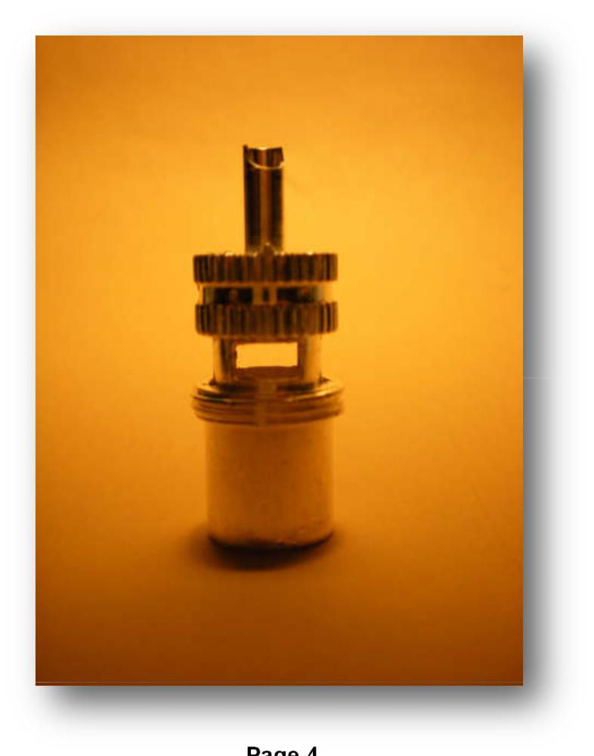

Page 4

W4TJE Arrives at DXCC Honor Roll

By John Scott, K8YC

Back in April, 2018 CDXA’s Roving Reporter vis-ited Jack Emerson, W4TJE, at his home on the Blue Ridge. Jack had been a 15m band aficionado for many years and had a “stack” to prove it, but with the depth of the solar cycle, Jack decided enough was enough and he installed a tower with a dual band yagi for 40m and 30m. He’s been amazed what this long dreamed about setup has provided him during the nadir of the solar cycle.

Over the years, Jack had worked most of the DXCC entities, but chasing “wallpaper” had never been a top priority. When the urge came to finally figure out what his DXCC numbers really were, he methodically began posting to LoTW one contact for each entity that would add to his DXCC total. When I asked Jack how many entities he had en-tered, he thought it was somewhere over 320. I asked Jack if I could help get his “numbers” loaded to Club Log to have them included in the CDXA Club League scoring. When I downloaded Jack’s numbers from LoTW and loaded them to Club Log, we found that Jack had 325 entities after including those confirmations awaiting submission to ARRL.

Now, that fact awakened the competitive instincts in Jack! The listing showed Jack exactly what he still needed. Since April, a few QSL cards Jack had sent for arrived at his home. Then, in the first days of October, Jack worked Tristan da Cunha (ZD9) and Guantanamo Bay (KG4) on the week-end, and had them confirmed via LoTW before the weekend was over. Now only one more entity was needed. An Australian on American Samoa operat-ing as KH8/VK4MAP on 4 October was worked on 40m SSB and he promised Jack the QSL will be sent as soon as he returns home! Sometime in the coming months, Jack will have ARRL verify those remaining card-in-hand and LoTW confirmations, and Jack will officially be a member of the DXCC Honor Roll. In the meantime, his Club Log ac-count proudly shows 331 entities worked. Congrat-ulations, Jack.

October, 2018

LZ1GC Rides Again!!!

By John Scott, K8YC

If you go back to the May 2018 issue of The Pileup, you’ll see a writeup by Stan Vatev, LZ1GC, of his solo operator DXpedition to Temotu Prov-ince where he operated as H40GC. CDXF and CDXA both sponsored that DXpedition. In several of Stan’s earlier DXpeditions, he managed to have the licensing authorities issue callsigns with the let-ters “GC” in the suffix.

A week or so ago,the callsign 5W0GC appeared on DX Summit. Could Stan be back in the South Pa-cific again so soon? A quick check of QRZ.COM provided the answer. YES. Stan was at it again, and he has had some very good signals allowing me to easily work him on 5 bands between 80m and 15m. He’ll be operating as 5W0GC through Octo-ber 14 when he’ll move to Vanuatu to operate at YJ0GC.

On his way to Vanuatu, in Fiji, Stan will be joined by two operators, OM5ZW and OK2WM, and they’ll be operating from Vanuatu until 4 Novem-ber. If you need those two entities, get on the air.

Pun Phun

With Halloween right around the corner, it’s only appropriate that we experience a few moans and groans, so, read on fair readers. . . .

Did you hear about the fellow who had a phobia about over-engineered buildings? He had a

complex complex complex. (Bet you had to think about that one.)

It was learned among some competitors at WRTC in Wittenburg, Germany, there were some concerns about whether they would like the food. It turns out they were only the ones who always fear the wurst.

Did you hear about the mathematician who couldn’t afford lunch with the CDXA crowd? He could binomial.

Computer programmers make good dance teach-ers because they have algorithm.

Page 5

October, 2018

2018 CQWW Contests Coming In October And November

John Forbus, NV4A

URGENT: It's time to get ready for the CQ World Wide DX contests and CDXA's Contest Within A Contest (also known as CWAC). Both contests run for 48 hours. The sideband contest runs from 0000Z on 27 October (8pm EDT on the 26th) until 2359Z on 28 October. The CW contest begins at 0000Z November 24 (that's 7:00 PM Eastern Standard Time on the 23rd.) That's right, we switch from Daylight Savings Time to Standard Time between the side-band and the CW contest.

Once again we are offering several prizes to encourage participation in CWAC which should help our club score. The details are below, but first, as usual, PLEASE NOTE: CDXA needs every member’s help to improve our standings in the CQWW Club Competition. K5ZD, Randy, the former CQWW Contest Director and a top contester, gave a presentation in 2014 filled with tips on how to improve your single operator score. You can get to the video here. The presentation covers a whole raft of subjects such as station layout, skills development, operating strategy, etc. Even if you’ve watched it before, it’s still worth checking out again before the contest starts. In summary, EVERY point counts, so even if you have limited operating time, please get on the air and help us out. Even if you aren’t really a contester, look at this as a chance to add ATNOs (all time new ones), new band/mode entities, and “year entities” for the DX King Contest. A plus about contesting is that a pretty high percentage of contesters upload their logs to LoTW, so you’ll have a better than average chance to get that needed entity confirmed quickly. Now, for those prizes to add some additional incentive to participate. We are bringing back the Outback Steakhouse gift cards which have been popular in the past. Remember they are also good at Carrabba's, and the Bonefish Grill. There are prizes for both serious efforts and more casual operations.

First place prizes—each winner will receive a $50 Outback Steak House gift card. These will be awarded in the cate-gories listed below. An individual can only win one prize. The Multi-op prize will only be awarded to an entrant whose score is high enough to have won one of the other first place prizes.

Top combined Phone and CW Score | Top Phone Score, low power | Top DXpedition score
Top Phone Score | Top CW Score, low power
Top CW Score | Top Multi-op score

Other prizes:

1000 or more QSO's total in the Phone and CW contests—each winner will receive a $25 gift card for Outback Steak House.

500 or more QSO's—a photo printed CDXA certificate and a chance in a raffle for a $25 gift card.

250 or more QSO's—a chance in a raffle for a $25 gift card.

Only members whose scores are eligible for the club competition as defined in the contest rules on the CQWW web site can win a gift card. That means your station must be within 250 miles of our club center, which is the center of EM95xe or Lat 35.186667, Lon -80.043333, or you must be on a DXpedition and live within the radius of the club center. If you aren't sure if you are within our radius please check with me before the contest.

All CDXA members are eligible for the CDXA certificates. Again this year all logs must be submitted to CQWW within five days after the end of the contest. That's no later than 2359Z Nov 2 for the sideband competition, and 2359Z Nov 30 for the CW competition. Please get your log summaries, including Operating Class, number of coun-tries and zones worked, and your final claimed score to me (jtfnv4a@aol.com) as soon as possible after the contest. Also be sure to show “Carolina DX Association” as your club identifier in the log summary sent to CQWW—don’t abbreviate any portion of the identifier or your score won’t be counted in CDXA’s scoring.

Prizes will be based on your claimed score and will be presented at the Holiday dinner. Let me know if you have any questions; also let me know if you are planning a DXpedition for CQWW.

So, start getting ready now. Get your contest software updated, make sure your rig and antennas are all working (especially after Florence!), get plenty of sleep before the contests start …and, most importantly, have fun!

Page 6

October, 2018

The Back Page

DX King competition continues. Don’t tell the competitors that there is no DX to be had. As usual the guys near the top have already worked over 200 entities in 2018 and all have worked all 40 CQ Zones. See Page 3.

The FT8 Challenge has seemed to have captured the fancy of many in 2018. There are 18 folks in the hunt and fully one third of those can claim to have worked over 1500 unique grid squares so far in 2018. With two to three minutes needed to complete an FT8 contact and the number of unique grids squares worked, some serious hours in the chair have been spent by the leaders. With a little over 2-1/2 months left, there is still time to earn 200 grid squares and get your name in the raffle at years end.

Did you ever struggle to fill in those little solder holes when affixing a PL-259 to your feedline? Do you want a sure, carefree solution for your connectors? Don Daso lets us know what he deems a top notch connector based on years of installing them for clients of his tower business.

One can climb the highest mountain one step at a time. After years of working others primarily for the fun of just making a con-tact, Jack Emerson, W4TJE, decided to actually enter his logs to LoTW. The result will put Jack on the DXCC Honor Roll as soon as he gets ARRL to confirm the last few entities for which he holds cards or has pending LoTW credits. See Page 5.

Need Samoa or Vanuatu? Our friend, Stan LZ1GC who CDXA sponsored for his Temotu Province DXpedition last year, is in Samoa until 14 October and has had great signals the past weeks. After that, he’ll move on to Vanuatu. See Page 5.

The two biggest contests of the year are upon us. The CQ World Wide DX Contest (CQWW)—Phone version and CW Ver-sion—offer opportunities to work every ham in every DXCC entity. Want to earn DXCC in a single weekend? Here’s your chance, and in doing it, you might just earn a prize from CDXA for your participation. See Page 6.

——-o——-O——-o——

Hope to see you at the CDXA Bar-B-Que this weekend!

Page 7

